NUMERICAL OPTIMISATION

PRACTICAL FILE

Bhaskar malik

16020

Section a

**Q.1**

import numpy as np

def objective_function(x):

    return x**2 + 4*x + 4

def gradient(x):

    return 2*x + 4

def line_search(initial_x, learning_rate, epsilon):

    x = initial_x

    iteration = 0

    while True:

        gradient_x = gradient(x)

        new_x = x - learning_rate * gradient_x

        # Check for convergence

        if abs(new_x - x) < epsilon:

            break

        x = new_x

        iteration += 1

    return x, objective_function(x), iteration

# Initial parameters

initial_x = 0.0

learning_rate = 0.1

epsilon = 1e-6

result_x, result_min, iterations = line_search(initial_x, learning_rate, epsilon)

print(f"Minimum value found at x = {result_x}")

print(f"Minimum objective function value = {result_min}")

print(f"Iterations: {iterations}")

**OUTPUT:**

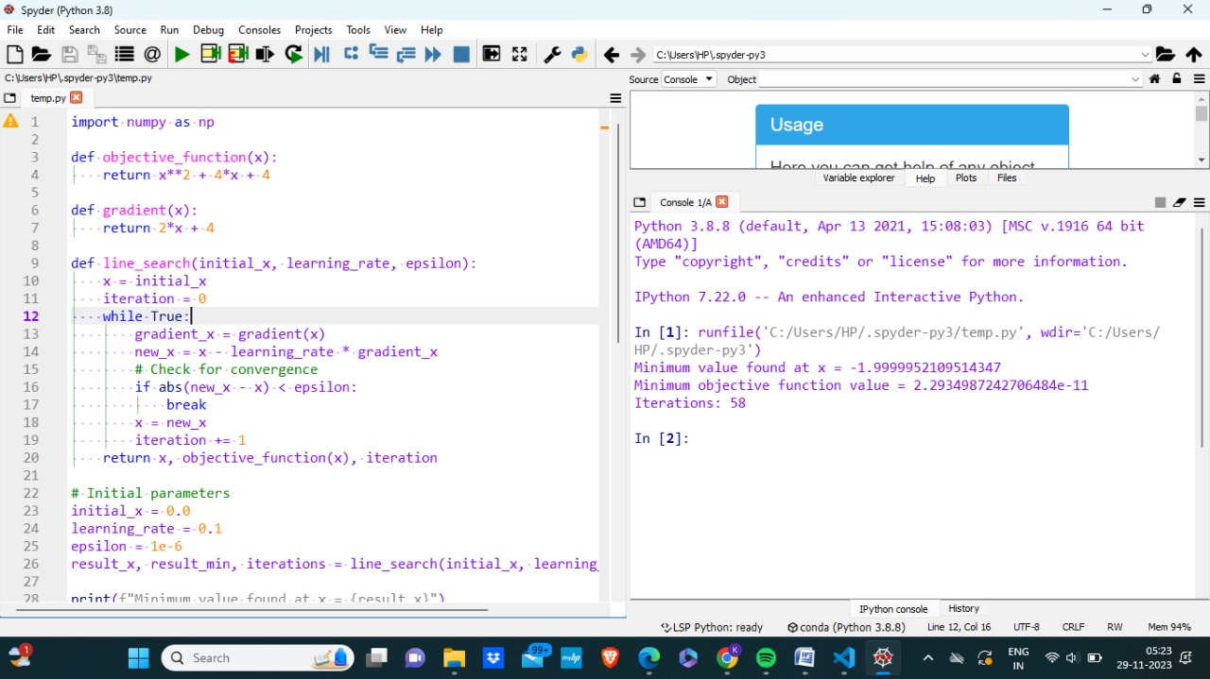

**Q.2**

import matplotlib.pyplot as plt

# define constants of function

c1=4

c2=5

points=[[0,0],[4,0],[0,3],[2,1]]

z=[]

for i in points:

value=c1*i[0]+c2*i[1]

z.append(value)

print("value at ",i,"is : ",value)

Max=points[z.index(max(z))]

print("optimal point is :",Max)

# x and y are define

x = [i for i in range(0,10)]

y = [(6-2*i) for i in x]

y1= [(9-2*i) for i in x]

# plot x and y

plt.plot(x, y)

plt.plot(x, y1)

# to make grid in graph

plt.grid(True)

# to limit axis of x and y

plt.xlim(0,12)

plt.ylim(-26,13)

# to stlye line in figure

plt.plot(x,y,ls="dotted",marker="s",c="b",lw="2")

plt.plot(x,y1,ls="dotted",marker=".",c="r",lw="2")

# to label axis

plt.xlabel('x - axis')

plt.ylabel('y - axis')

# to label graph

plt.title('My first graph!')

# to show graph

plt.show()

**

**Q.3**

import sympy as sp

x1,x2=sp.symbols ('x1 x2')

function=100* (x2-x1*2) **2+(1-x1)*2

gradient=[sp.diff (function, x1), sp.diff (function, x2)]

hessian=[[sp.diff (gradient [0], x1), sp.diff (gradient [0],x2)], [sp.diff (gradient [1], x1), sp.diff (gradient[1],x2)]]

print("Gradient:")

print(gradient)

print("\nHessian:")

print(hessian)

**OUTPUT:**

**Q.4**

import numpy as np

from scipy.optimize import differential_evolution

def objective_function(x):

    return -10 * np.cos(np.pi * x - 2.2) + (x + 1.5) * x

bounds = [(-10, 10)]

result = differential_evolution(objective_function, bounds)

min_x = result.x

global_min_val = result.fun

print("Global Optimal Solution:")

print(f"x = {min_x[0]}")

print(f"f(x) = {global_min_val}")

**OUTPUT:**

**Q.5**

import numpy as np

import matplotlib.pyplot as plt

# Define the function f(x)

def objective_function(x):

return -10 * np.cos(np.pi * x - 2.2) + (x + 1.5) * x

# Generate x values

x = np.linspace(-5, 5, 20)

print(x)

y = objective_function(x)

print(y)

plt.plot(x, y, label='f(x) = -10Cos(pi x - 2.2) + (x + 1.5) * x')

plt.xlabel('x')

plt.ylabel('f(x)')

plt.title(' Function f(x)')

plt.grid(True)

min_y = min(y)

min_x = x[np.argmin(y)]

plt.scatter(min_x, min_y, color='blue', label=f'Minimum: ({min_x}, {min_y})')

plt.legend()

plt.show()

print("Global optimal solution is", min_x)

print(" Optimal function value is", min_y)

**OUTPUT:**

**Q.6**

import pulp

import matplotlib.pyplot as plt

lp_problem = pulp.LpProblem("LPP", pulp.LpMaximize)

x = pulp.LpVariable("x", lowBound=0)

y = pulp.LpVariable("y", lowBound=0)

lp_problem += 3 * x + 2 * y

lp_problem += x <= 4

lp_problem += y <= 6

lp_problem += 2 * x + y <= 12

lp_problem.solve()

print("Status:", pulp.LpStatus[lp_problem.status])

print("x =", x.varValue)

print("y =", y.varValue)

print("Optimal Value =", pulp.value(lp_problem.objective))

plt.plot(x.varValue, y.varValue, 'ro', label="Optimal Value")

plt.fill([0, 4, 4, 3, 0], [0, 0, 4, 6, 6], 'b', alpha=0.2)

plt.xlabel("x")

plt.ylabel("y")

plt.title("Graphical Solution of LPP")

#plt.legend(loc ="upper right")

plt.legend(bbox_to_anchor=(0.25,1.15), ncol=7)

plt.grid(True)

**OUTPUT:**

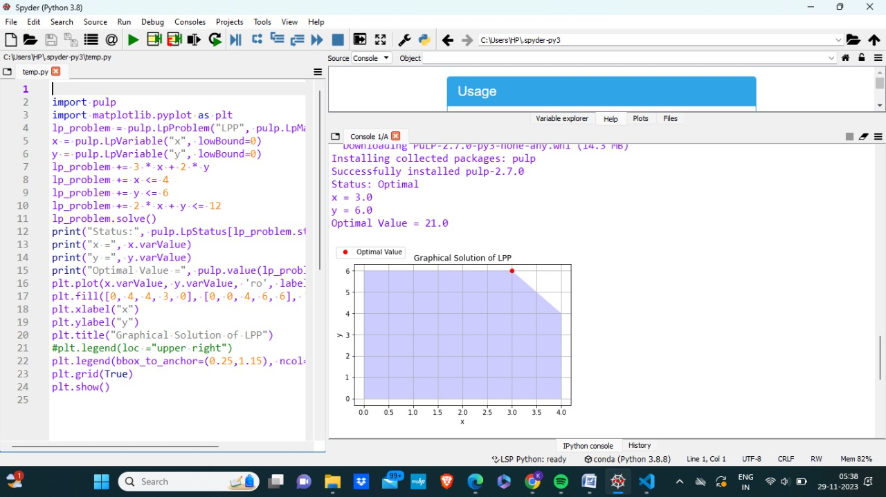

import numpy as np

from matplotlib import pyplot as plt

plt.rcParams["figure.figsize"] = [10.50, 3.50]

plt.rcParams["figure.autolayout"] = True

c1=2

c2=3

def f(x):

return x**2

x = np.linspace(-5, 1, 5)

z=[]

for i in x:

value=c1*i+c2*f(x)

z.append(value)

print("value at ",i,"is : ",value)

Max=x.all()

print("\noptimal point is :",Max)

plt.plot(x, f(x), color='red')

plt.show()

**OUTPUT:**

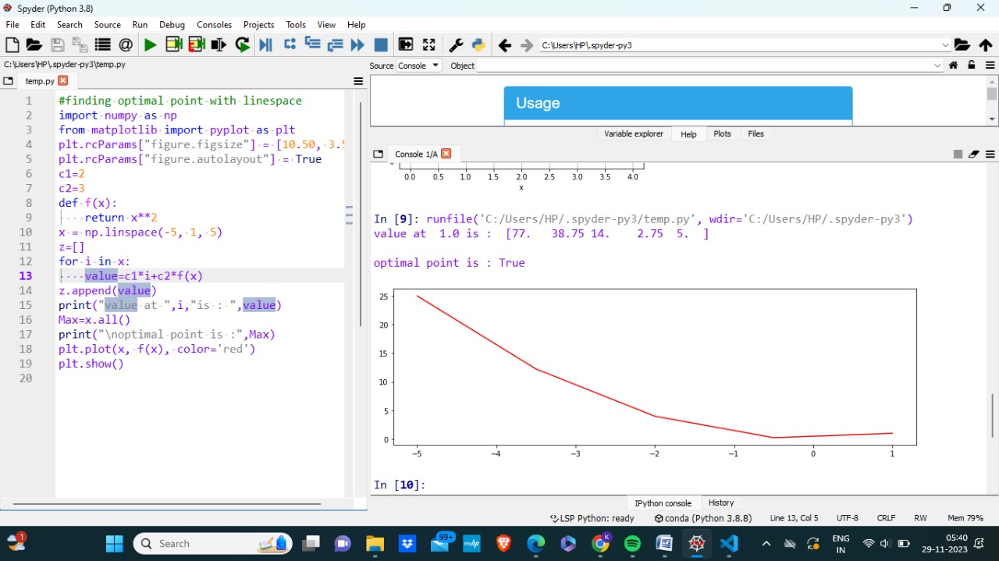

**Q.7**

from sympy import symbols, diff, solve, Matrix

import numpy as np

from scipy.optimize import minimize

# Define symbols

x, y, l = symbols('x y lambda')

# Define the objective function and constraint

f = x**2 + y**2

g = x + y - 1

# Define the Lagrangian

L = f - l * g

# Compute partial derivatives

partials = [diff(L, var) for var in (x, y, l)]

# Solve the system of equations

solution = solve(partials, (x, y, l), dict=True)[0]

# Extract the optimal values

optimal_x = solution[x]

optimal_y = solution[y]

# Compute the Hessian matrix

hessian_list = [[diff(L.diff(var1), var2) for var1 in (x, y, l)] for var2 in (x, y, l)]

hessian_matrix = Matrix(hessian_list)

# Display the Hessian matrix

print("Hessian Matrix:")

print(hessian_matrix)

# Determine the nature of the stationary point

hessian_determinant = hessian_matrix.det()

if hessian_determinant > 0:

    print("Stationary point is a local minimum.")

elif hessian_determinant < 0:

    print("Stationary point is a local maximum.")

else:

    print("Second-order test inconclusive (saddle point or test fails)")

# Display the optimal solution

print("\nOptimal solution:")

print(f"x: {optimal_x}")

print(f"y: {optimal_y}")

# Finding optimal solution using scipy.optimize.minimize

# Define the objective function

def objective_function(x):

    return x[0]**2 + x[1]**2

# Initial guess

initial_guess = [0.0, 0.0]

# Minimize the objective function

result = minimize(objective_function, initial_guess, method='BFGS')

# Extract the optimal solution

optimal_solution = result.x

minimum_value = result.fun

# Print the results

print("\nOptimal Solution (using scipy.optimize.minimize):", optimal_solution)

print("Minimum Value:", minimum_value)

**OUTPUT:**

